Solve the equation.

- 4p-2+9p +12

- 12d+4d-7-6d= -4d

- -8x+14= 3(x+2) -2(4x-7)

- 12y+23-5y= 72

- Two joggers run 8 miles north and then 5 miles west. What is the shortest distance, to the nearest tenth of a mile, they must travel to return to their starting point?

- Find the length of the unknown side in the right triangle to the nearest tenth. 7.7

- The ice cream cone company is trying to decide how much space will fit inside their Guinness Record Breaking ice cream cone. If the height of the cone is 240 cm and the diameter is 398 cm.

- Determine the volume of a sphere with a radius of 3.6 cm, both in terms of $π$ and to the nearest tenth. Use 3.14 for $π$.

- 2(6+4n) > 12-8n (GRAPH)

- 5 - 3x – 12 $≥$ 19

- Solve for the indicated variable. Solve 2x+4y-5=6z for x.

- The admission fee at a small fair is $1.50 for children and $4.00 for adults. On a certain day, 2200 people enter the fair and $5050 is collected. How many children and how many adults attended?

- Find the distance between (4, 9) and (1,-6) to the nearest tenth?

- Find the volume of the cylinder to the nearest cubic foot. Use a calculator.

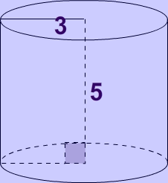

- Solve for $A=πr^{2}$ for r.

- Keisha charges a $1.75 flat rate to braid hair in addition to $0.65 per braid. Lanoria has no more than $10 to spend. How many braids can she get?

- $({6p^{3})}^{\frac{1}{4}}$

- $\sqrt[7]{3x}$

- $12\sqrt{j}$

- ${15x}^{\frac{1}{5}}$

