NAME

Input-Output Machine
Our input-output machine takes a number [x], operates on the number, and changes it to a new number [y]. Below are some input-output machines, the input [x], and the output [y]. Can you figure out the rule for what the machine did to the input?

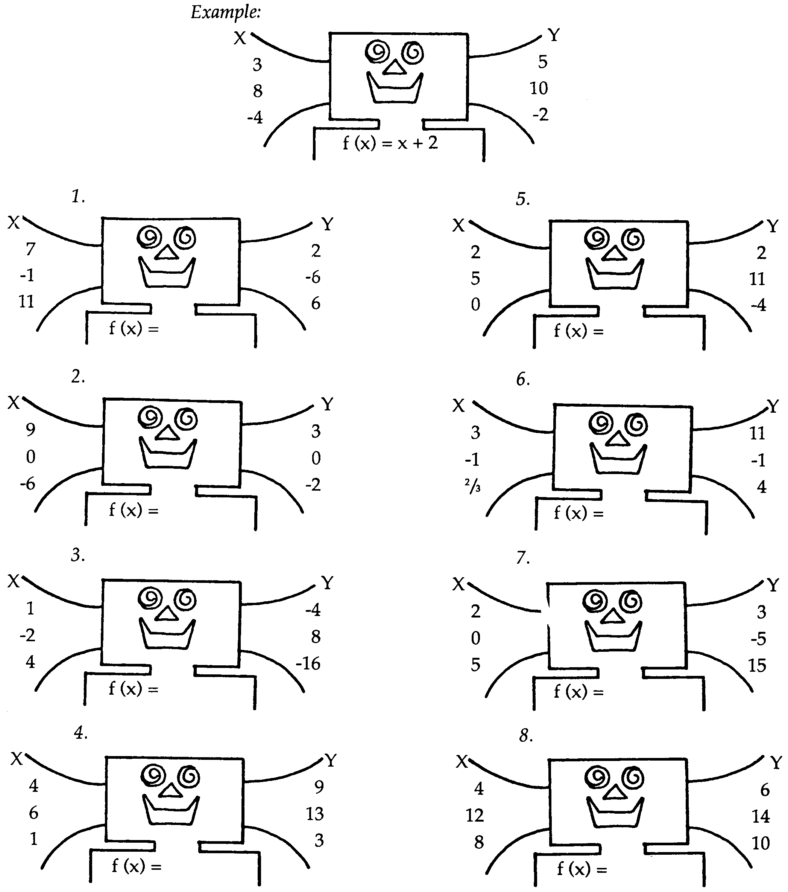
$y=$
$y=$
$y=$
$y=$
$y=$
$y=$
$y=$
$y=$
$$y= x + 2$$

