Common Core Math 1 Name ___________________
Univariate Data Date _______________
Boxplots and Outliers

1. Given the following grades on an English 11 test:
91, 98, 87, 76, 100, 45, 72, 85, 92, 88, 87, 90, 91, 66, 100, 99, 67, 85, 79, 80, 85
Do you think there will be an outlier?

Calculate the 5 number summary and any outliers.

Remove the outlier and recalculate the 5 number summary. What changes have occurred?

Why would it be useful to remove the outlier to look at this data? Explain a scenario in which we would want to leave the outlier in and a scenario in which we would want to remove the outlier.

2. Given the box plot below, create a scenario that would produce this data.
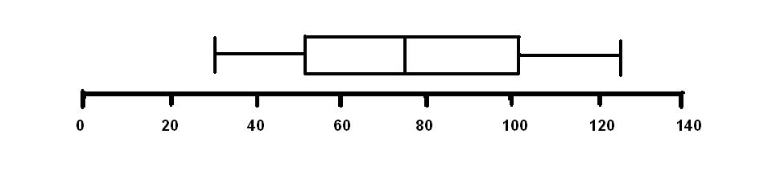

3. In the table below, the public high school graduation rates for 1992-1993 are given for each state, including the District of Columbia. (Note: the rates are listed in ascending order)

State | Rate | State | Rate | State | Rate
Louisiana | 56.3 | Oregon | 72.6 | Arkansas | 78.4
South Carolina | 59.2 | Kentucky | 72.7 | New Hampshire | 78.4
Texas | 59.4 | Missouri | 72.8 | Kansas | 80.3
Florida | 61.4 | Alaska | 73.4 | Pennsylvania | 80.6
Georgia | 61.6 | Virginia | 74.2 | Utah | 80.7
Alabama | 61.7 | Maine | 74.3 | Connecticut | 80.8
Mississippi | 63.5 | Hawaii | 74.9 | Vermont | 82.0
DC | 64.6 | Ohio | 75.0 | Idaho | 82.3
New York | 65.4 | Indiana | 75.1 | Wisconsin | 83.5
Tennessee | 67.4 | Colorado | 75.3 | New Jersey | 85.8
North Carolina | 67.6 | Rhode Island | 75.5 | North Dakota | 85.8
California | 67.9 | Maryland | 75.6 | Montana | 86.7
New Mexico | 68.2 | Washington | 75.6 | Nebraska | 86.9
Nevada | 69.6 | Oklahoma | 75.9 | Wyoming | 86.9
Michigan | 69.9 | West Virginia | 77.9 | Iowa | 87.5
Deleware | 70.2 | Illinois | 78.0 | Minnesota | 89.1
Arizona | 72.0 | Massachusetts | 78.1 | South Dakota | 89.1
- Find the mean

- Find the median

- Which measure of center would be the most appropriate to use? Support your answer with a reason.

- Calculate the 5 number summary

- Find the range.

- Find the interquartile range. Interpret what this gives you.

- List the 7 states that have the highest graduation rates. What region of the country to they represent?

- List the 7 states that have the lowest graduation rates. What region of the country do they represent?

- Name some factors that might account for your answers to “g” and “h.”

- Are there any outliers?

- What graduation rate would a state have to be over or under to be considered an outlier?

- Create an outlier. Identify it here and explain (good or bad graduation rate?).

- Add this outlier to the data. Recalculate the mean and median.

- As a North Carolinian, what does this outlier do for the “standing” of your state?

