- Paula is cross-training for a triathlon in which she cycles, swims, and runs. Before designing an exercise program for Paula, her coach consults a table listing rates for calories burned in various activities.

Cross-training activity | Calories burned  (per min)
Walking | 3.2
Bicycling | 3.8
Swimming | 6.9
Jogging | 7.3
Running | 11.3
- On Monday, Paula starts her workout by biking for 30 minutes and then jogging. Write an equation for the calories she burns on Monday in terms of the number of minutes she jogs.

- On Wednesday, Paula starts her workout by swimming for 30 minutes and then running. Write an equation for the number of calories she burns on Wednesday in terms of the number of minutes she runs.

- On Friday, Paula starts her workout by swimming 15 minutes, then running. Write an equation for the number of calories she burns on Friday in terms of the number of minutes she spends running.

- How many total calories does Paula burn on each day described in 3a-c if she does a 60-minute workout?

- You can represent linear relationships with a graph, a table or values, an equation, or a rule stated in words. Here are two linear relationships. Give all the other ways to show each relationship. (These representations do not go along with Paula’s workout!)
a. b.
x | y
-2 | -7
-1 | -4
0 | -1
3 | 5
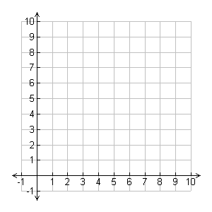

Table: Graph:
Function: Function:

Answer Key

1. a. y = 114 + 6.9x
b. y = 207 + 7.3x
c. y = 160.5 + 11.3x
d. Monday: 321 calories; Wednesday: 426 calories; Friday: 499.5 calories

x | y
1 | 5
2 | 7
3 | 9
4 | 11
2. a. y = 2x + 3 Students answers will vary

b. y = 3x – 1 Students answers will vary

