Composition of Transformations:

Composition of Transformation: A composition of two transformations is a transformation in which a second transformation is performed on the image of a first transformation

Glide reflection: a composition of a translation and a reflection in a line parallel to the direction of the translation

**Guided Examples:**

Given DEF with D(3, 1), E(-3, 2), and F(-2, -2). Find the image points after:

1. 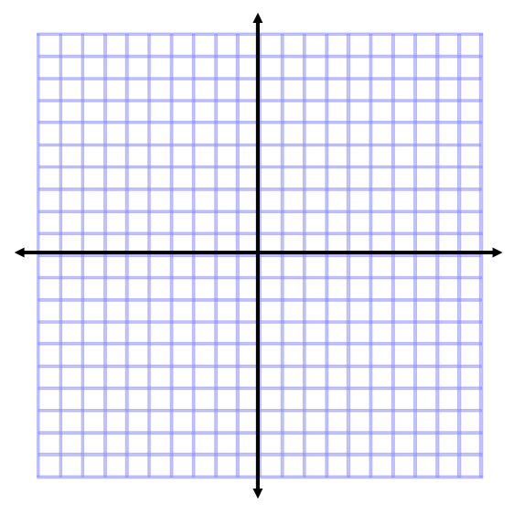 A reflection over the x-axis, then a dilation of  Stress the importance of completing one transformation at time—IN ORDER.
2. A translation of (x, y) → (x - 5, y + 2), then a rotation of 90° counter clockwise
3. A reflection over y = x, then a translation of (x, y) → (x + 1, y – 4)



1. Triangle DEF has vertices D(3, -4), E(2, -2), and F(0, 1). Find the coordinates after a glide reflection composed of the translation (x, y) → (x, y - 2) and a reflection in the y-axis.



“You Try”

Given DEF with D(3, 1), E(-3, 2), and F(-2, -2). Find the image points after:

1.  A rotation of 180° counter clockwise, then a dilation of 2.
2. A reflection over y = x, then a rotation of 270° counter clockwise
3. Triangle ABC has vertices A(3, 2), B(-1, -3), and C(2, -1). Find the coordinates after a glide reflection of (x, y) → (x + 3, y) and a reflection in y = 1.