Name __________________________________________________ **Station 1**

Complete the sentences with **congruent or supplementary**

When parallel lines are cut by a transversal then,

1. Corresponding angles are ________________________.
2. Alternate Interior Angles are ________________________.
3. Same Side Interior Angles are ________________________.
4. Alternate Exterior Angles are ________________________.

Name __________________________________________________ **Station 2**

Use the diagram to answer the questions that follow.

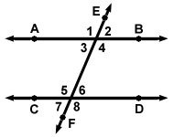

1. *m*2 is 70°. Find the *m*6.
2. *m*3 = 5*x* and *m* **6 is 3*x* + 8. Find the value of *x* and the measure of

**4 and **5.

Name __________________________________________________ **Station 3**

|  |  |
| --- | --- |
| 1. In triangle *DEF* the measure of angle *D* is 36 and the measure of angle *E* is 92. Find the measure of angle *F*. | 2. |
| 3. Find the value of x. Then, substitute x to find the value of Angle C.  A B  x  x + 20    C  5x + 20 | |

Name __________________________________________________ **Station 4**

Find the values of the given variables.

1.

50°

x°

65°

45°

2.

y°

109°

x°

Name __________________________________________________ **Station 5**

1. The measure of one angle of a triangle is twice the measure of a second angle. The measure of the third angle is 12 less than the sum of the other two. Find the measure of the angles of the triangle.

2. ∆ABC is similar to ∆DEF. Label the triangles. Identify all corresponding angles and sides.

i. ∠A corresponds to __________.

ii. ∠B corresponds to __________.

iii. ∠C corresponds to __________.

i. AB corresponds to __________.

ii. BC corresponds to __________.

iii. AC corresponds to __________.

Name __________________________________________________ **Station 6**

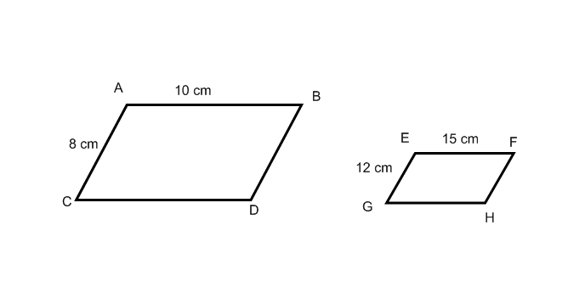**Are the following figures similar?**

1. 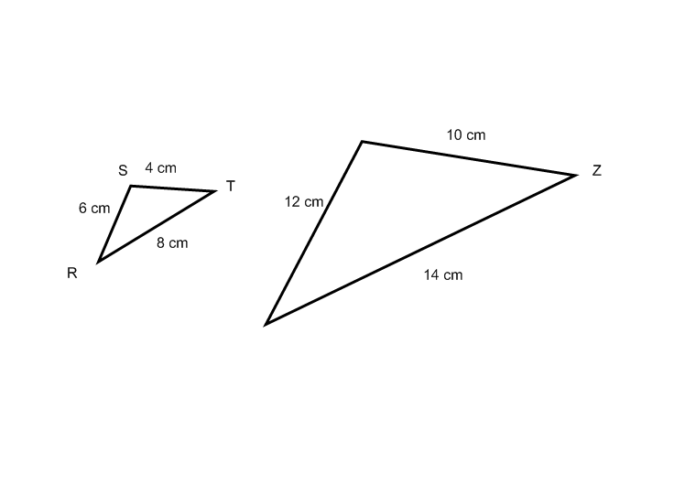

Name __________________________________________________ **Station 7**

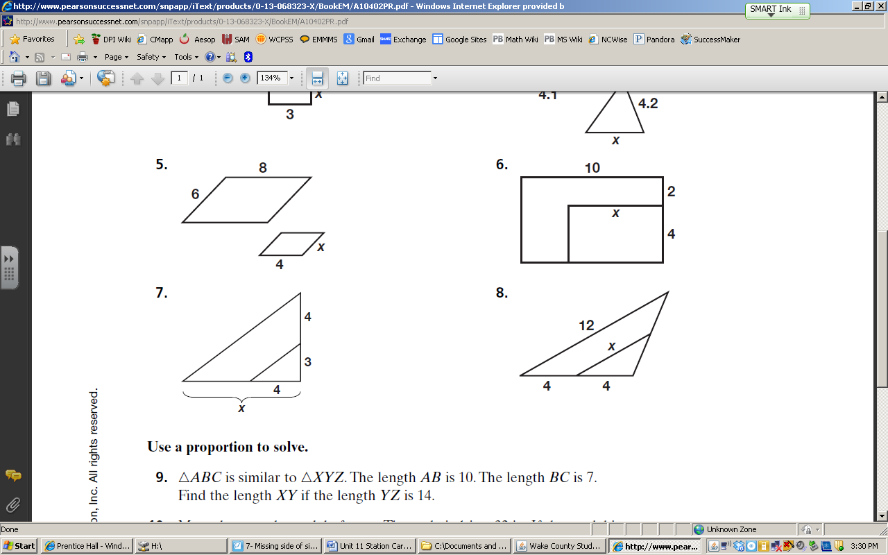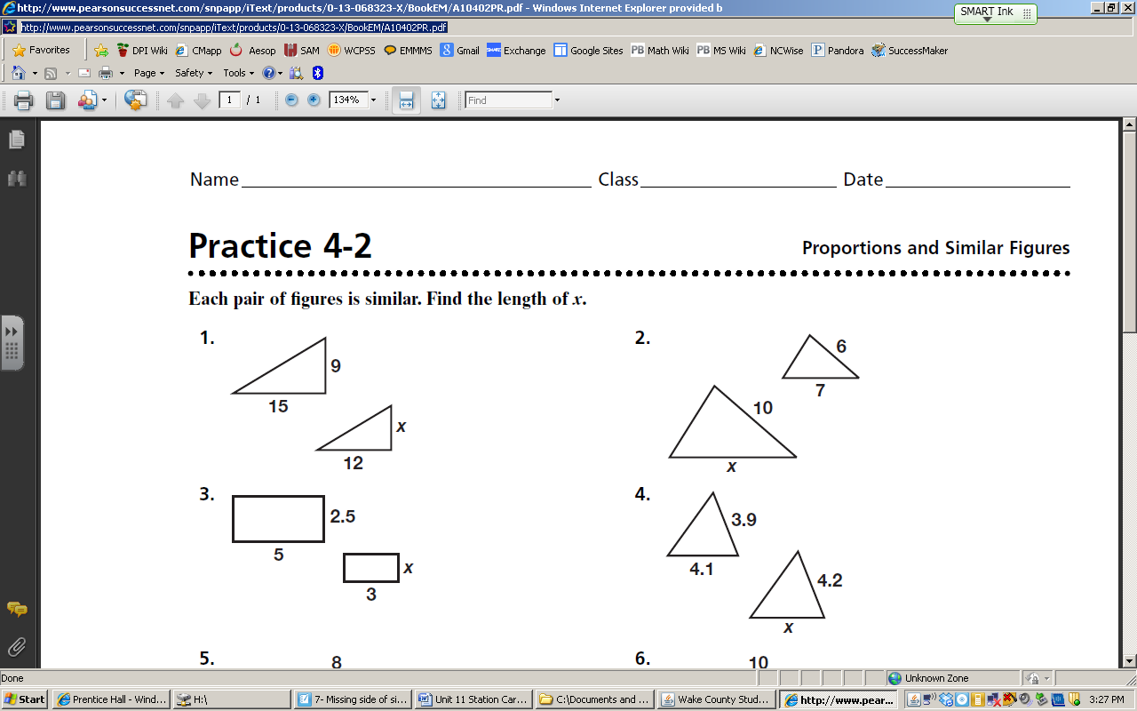**Find the missing side.**



Name __________________________________________________ **Station 8**

Use the diagram to answer the questions that follow.



1. Given the *m*8= 110°. Find the measure of as many of the other angles as possible.
2. *m* **4 = 20*x* + 20 and *m*6 is 10*x* + 10. Find the value of *x*.